Eren Zedeli
ID: 580199
ITM-324 Data Analytics for Business
Instructor: Andrey Aredakov
Summer 2016

1. Introduction…………..…………………………………………………………………3
2. Definitions…………..…………………………………………………………………..4
3. Analysis…………..……………………………………………………………………..4
3.1 T-test………….………………………….………………………………………..4
3.2 Liner Models….………………………….………………………………………..5
3.3 Plots……………………………………...………………………………………..7
References……..…………………………………………………………………………..9

1. Introduction
The purpose of our study is to determine how 8 different variables affect Heating Load and Cooling Load in residential buildings. The data set we analyzed comes from a research made by two Greek researchers at Oxford University, Athanasios Tsanas andAngeliki Xifara. They analyzed 12 different buildings located in Athens, Greece. The result of their study was the data set I analyzed, which contains the following variables:

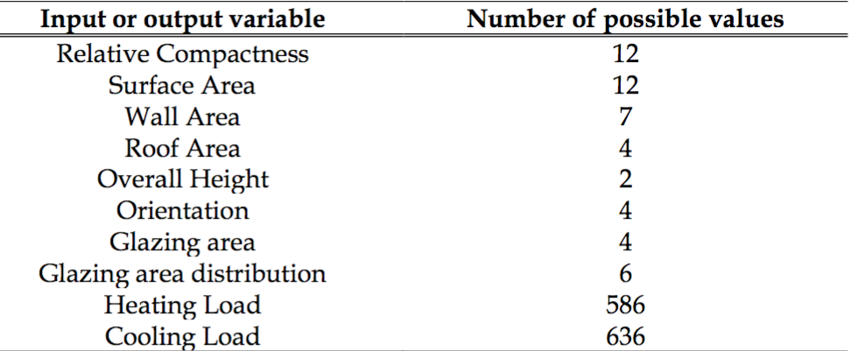

In order to compare two groups, I have separated the original data, whether Overall Height is 3.5 inches or 7 inches. The question that I am going to answer is how Heating Load is affected by Surface Area, whether Overall Height is 3.5 inches or 7 inches (how far the sensor from the roof).

2. Definitions
The heating load is the amount of heat energy that would need to be added to a space to maintain the temperature in an acceptable range.
Overall height is the height measured from the roof of the sensors used to perform the study.
Surface Area is the total area of a three-dimensional object.
3. Analysis
I have 768 observations, so CLT theorem is applied. Also, dataset is close to normal, and I will use parametric method.
Dataset that I am going to compare will be:
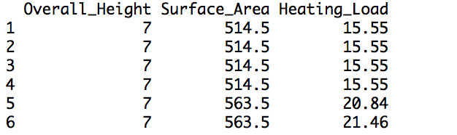
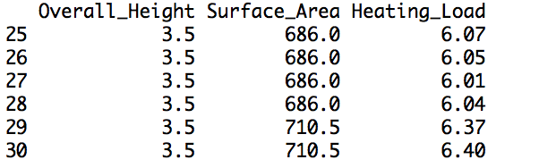
3.1 T-test
First of all, I have compared Heating Load for each Overall Height by using t-test. After the t-test analysis, I got the result below:
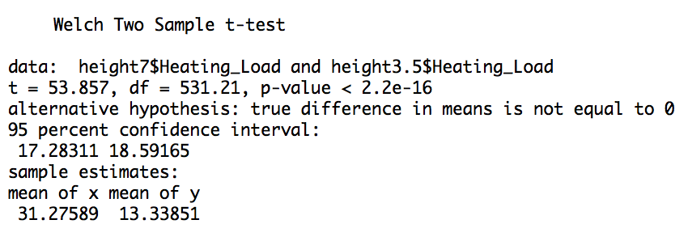
The mean difference of heating load whether the sensor is 3.5 inches or 7 inches far from the roof is 17.93738, and it is in in my CI. In other words, various of the data will be in this confidence interval (17.28311, 18.59165)
Heating loads are not same for two groups (height=7 and height=3.5) because p-value is 2.2e-16, which is less than 0.05. Simply, two distributions are different. In other words, I could say that the probability of two distribution can conflict is pretty less.
3.2 Linear Models
After t-test, I did fit two linear models for Overall Height=3.5 inches and Overall Height=7 inches
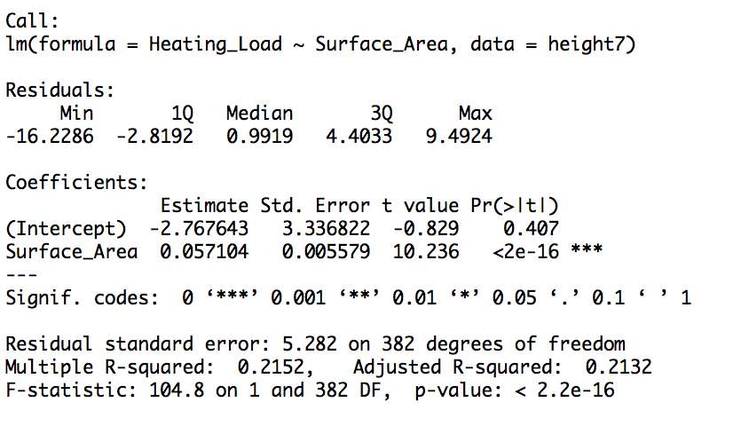

For Height=7 inches
Heating Load = -2.767643 + 0.057104 * Surface Area
For every additional foot square Surface Area, heating load is expected to increase by 0.057104 joule.
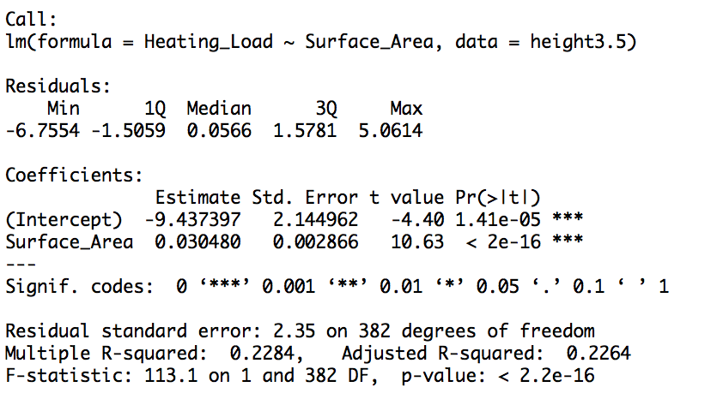
For Height=3.5 inches
Heating Load = -9.437397 + 0.030480 * Surface Area
For every additional foot square Surface Area, heating load is expected to increase 0.030480 by joule.
Slope for overall height=7 is (0.057104) greater than slope for overall height=3.5 (0.030480). That makes sense because if the sensor is 7 inches far from the roof that means not as close as the sensor is 3 inches far from the roof. To sum up, more energy is needed to maintain the temperature.

3.3 Plots
Before I made my plots, I did eliminate outliers by setting up my x limit and y limit.
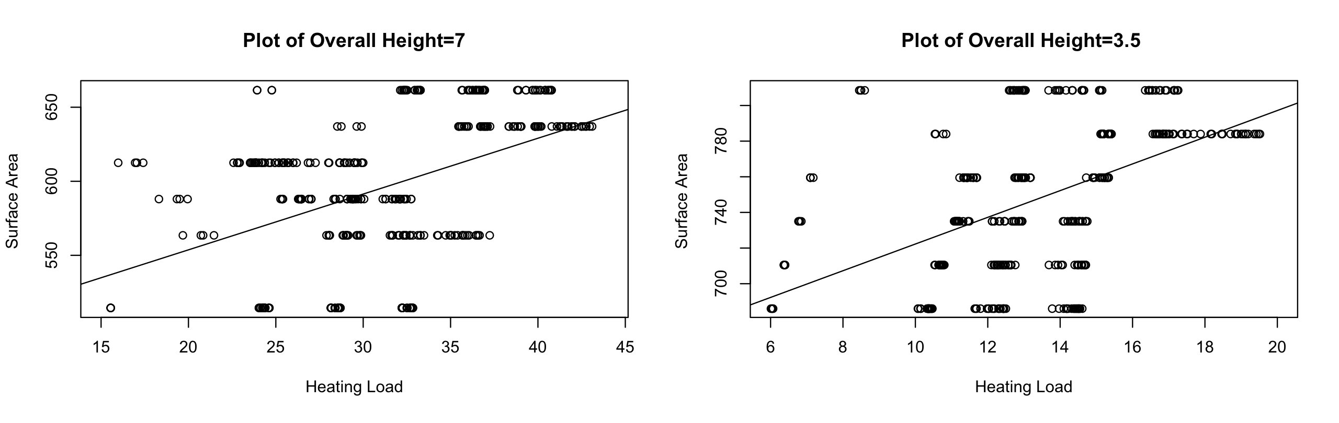
After I analyzed my plots, I realized that for more Surface Area, more energy is needed to maintain the temperature in acceptable range.
Kernel Density Plot
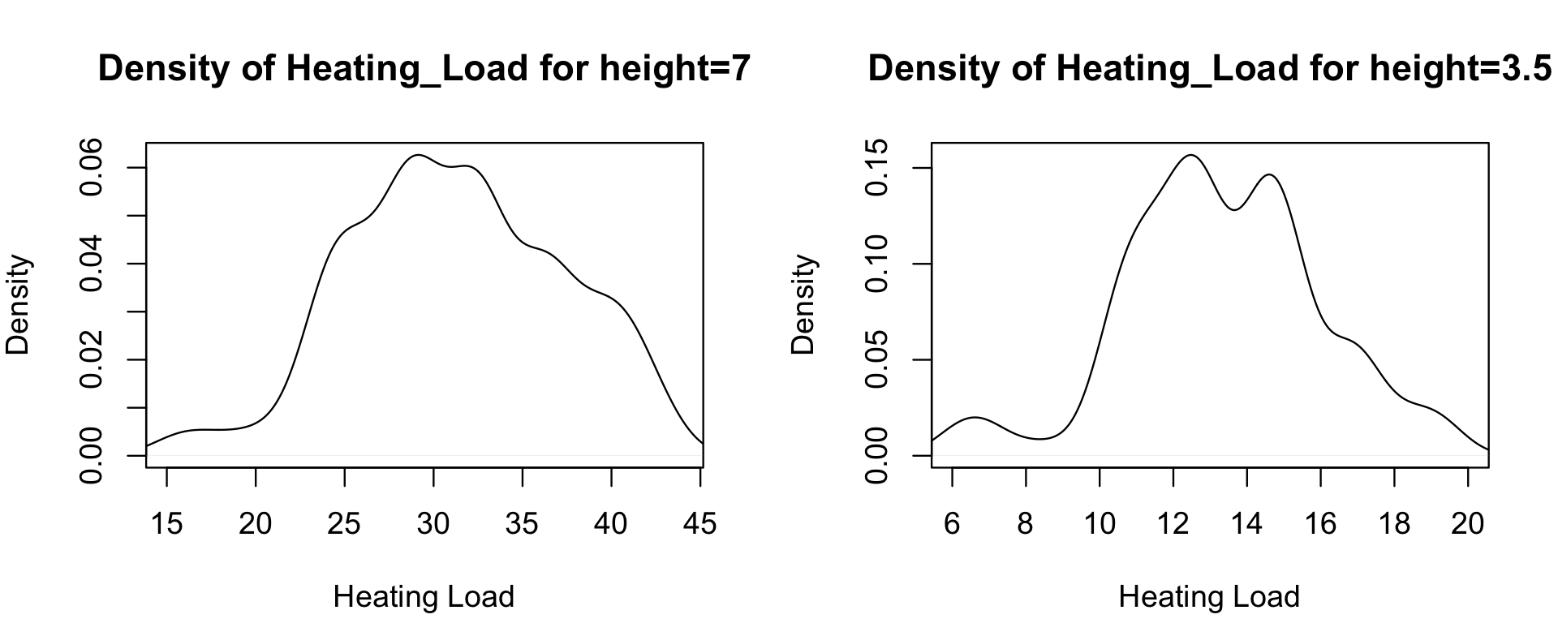
After I did my linear model plot, I did density plots. Heating load is changing between 6.01 and 19.52 for height=3.5 inches, and changing between 15.55 and 43.10 for height=7 inches. Again, density plots clearly shows that for height=7 heating load is higher than height=3.5. So density plot supports my linear models.
Heating Load Prediction
In order to predict Heating Load, I extended Surface Area 2 times, 3 times, and 4 times more. After that, I used predict() function to predict Heating Load.
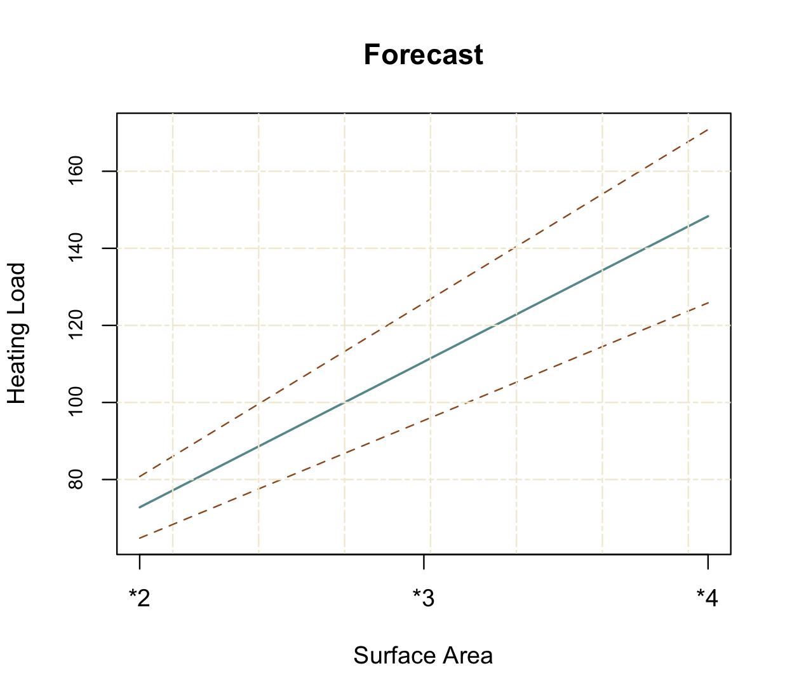
In conclusion, more energy is needed when surface area gets bigger. That makes sense, if the building gets bigger, you will need more energy to maintain the temperature in acceptable range. Also, I expect my mean in between CI that shown in the plot.

References
A. Tsanas, A. Xifara: 'Accurate quantitative estimation of energy performance of residential buildings using statistical machine learning tools', Energy and Buildings, Vol. 49, pp. 560-567, 2012
UCI Machine Learning Repository: Data Set. (n.d.). Energy efficiency Data Set. Retrieved from https://archive.ics.uci.edu/ml/datasets/Energy efficiency

